Profilig node js application

node –prof ./bin/www

node --prof-process bin/www

Shows the usage of languages in application

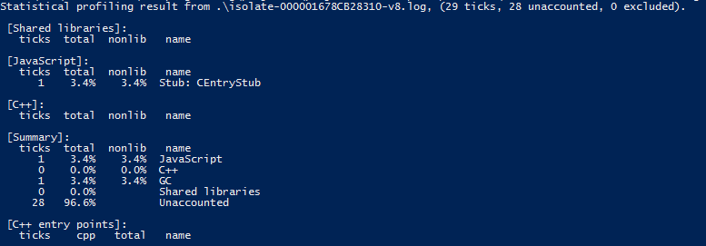

Bottom up (heavy) profile is where you can get information about “heavy” functions. Here there is nothing that is bottleneck in application.

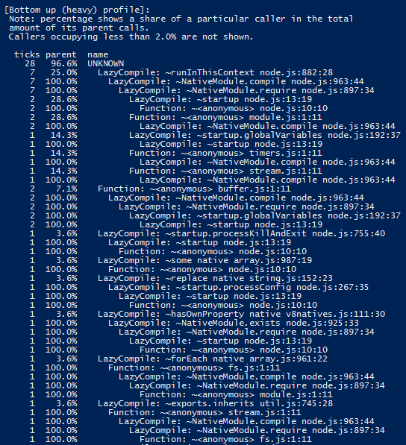

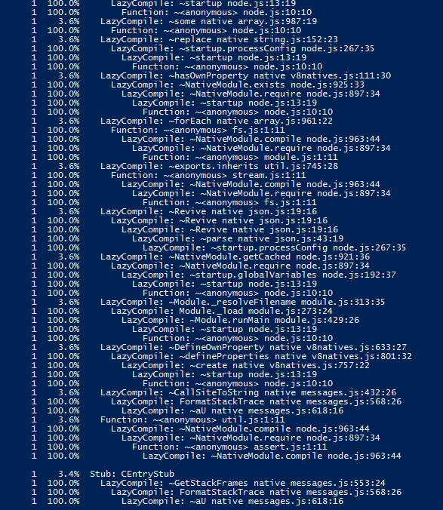

JMeter

